**1. Create the following tables with properly specifying Primary keys, Foreign keys and solve the following queries.**

**BRANCH (Branchid, Branchname, HOD)**

**STUDENT (USN, Name, Address, Branchid, sem)**

**BOOK (Bookid, Bookname, Authorid, Publisher, Branchid)**

**AUTHOR (Authorid, Authorname, Country, age)**

**BORROW (USN, Bookid, Borrowed_Date)**

Execute the following Queries:

i.List the details of Students who are all studying in 2nd sem MCA.

ii.List the students who are not borrowed any books.

iii. Display the USN, Student name, Branch_name, Book_name, Author_name, Books_Borrowed_Date of 2nd sem MCA Students who borrowed books.

iv. Display the number of books written by each Author.

v.Display the student details who borrowed more than two books.vi.Display the student details who borrowed books of more than one Author.

vii.Display the Book names in descending order of their names.

viii.List the details of students who borrowed the books which are all published by the same publisher.

CREATE TABLE BRANCH(

BRANCHID INT PRIMARY KEY,

BRANCHNAME VARCHAR(30),

HOD VARCHAR(30)

);

INSERT INTO BRANCH VALUES (1,'MCA','AMAR');

INSERT INTO BRANCH VALUES (2,'MBA','AKBAR');

INSERT INTO BRANCH VALUES (3,'MTECH','ANTONY');

CREATE TABLE STUDENT(

USN VARCHAR(30) PRIMARY KEY,

NAME VARCHAR(30),

ADDRESS VARCHAR(30),

BRANCHID INT REFERENCES BRANCH(BRANCHID),

SEM INT

);

INSERT INTO STUDENT VALUES ('1001','LOKESH','BANGALORE',1,2);

INSERT INTO STUDENT VALUES ('1002','AKSHAY','BANGALORE',1,2);

INSERT INTO STUDENT VALUES ('1003','MANOJ','BANGALORE',2,1);

INSERT INTO STUDENT VALUES ('1004','AMITH','SHIMOGA',3,1);

INSERT INTO STUDENT VALUES ('1005','ABHI','BANGALORE',1,2);

CREATE TABLE AUTHOR(

AUTHORID INT PRIMARY KEY,

AUTHORNAME VARCHAR(30),

COUNTRY VARCHAR(30),

AGE INT

);

INSERT INTO AUTHOR VALUES (1,'DENNIS','US',56);

INSERT INTO AUTHOR VALUES (2,'RAMAKRISHNA','INDIA',56);

INSERT INTO AUTHOR VALUES (3,'JAMES','US',56);

INSERT INTO AUTHOR VALUES (4,'RITCHE','UK',56);

CREATE TABLE BOOK(

BOOKID INT PRIMARY KEY,

BOOKNAME VARCHAR(30),

AUTHORID INT REFERENCES AUTHOR(AUTHORID),

PUBLISHER VARCHAR(30),

BRANCHID INT REFERENCES BRANCH(BRANCHID)

);

INSERT INTO BOOK VALUES(1,'JAVA',1,'PEARSON',1);

INSERT INTO BOOK VALUES(2,'C',1,'MC HILL',1);

INSERT INTO BOOK VALUES(3,'C++',2,'PEARSON',1);

INSERT INTO BOOK VALUES(4,'DBMS',3,'PEARSON',2);

INSERT INTO BOOK VALUES(5,'OS',4,'PEARSON',3);

CREATE TABLE BORROW(

USN VARCHAR(20) REFERENCES STUDENT(USN),

BOOKID INT REFERENCES BOOK(BOOKID),

BORROW_DATE DATE

);

INSERT INTO BORROW VALUES ('1001',1,'12-JAN-2021');

INSERT INTO BORROW VALUES ('1001',2,'12-JAN-2021');

INSERT INTO BORROW VALUES ('1001',3,'12-JAN-2021');

INSERT INTO BORROW VALUES ('1002',1,'12-JAN-2021');

INSERT INTO BORROW VALUES ('1003',4,'12-JAN-2021');

INSERT INTO BORROW VALUES ('1003',5,'12-JAN-2021');

**NOTE: IF ABOVE DATE FORMAT NOT WORKS TRY THIS ONE**

**INSERT INTO BORROW VALUES ('1003',5,'2021-01-12');**

**i. List the details of Students who are all studying in 2nd sem MCA**

SELECT * FROM STUDENT

WHERE SEM = 2 AND BRANCHID IN (

SELECT BRANCHID

FROM BRANCH

WHERE BRANCHNAME = 'MCA'

);

USN NAME ADDRESS BRANCHID SEM

-------------- -------------- --------------- --------------- ----

1001 LOKESH BANGALORE 1 2

1002 AKSHAY BANGALORE 1 2

1005 ABHI BANGALORE 1 2

**ii. List the students who are not borrowed any books**

SELECT * FROM STUDENT

WHERE USN NOT IN(

SELECT USN

FROM BORROW

);

USN NAME ADDRESS BRANCHID SEM

----------- ------------ ---------------- ----------- ----

1004 AMITH SHIMOGA 3 1

1005 ABHI BANGALORE 1 2

**iii. Display the USN, Student name, Branch_name, Book_name, Author_name, Books_Borrowed_Date of 2nd sem MCA Students who borrowed books**

SELECT S.USN,S.NAME,BRANCHNAME,BOOKNAME,AUTHORNAME,BORROW_DATE

FROM STUDENT S,BOOK BK,BORROW BW,AUTHOR A,BRANCH B

WHERE S.USN = BW.USN AND S.BRANCHID = B.BRANCHID AND BK.AUTHORID = A.AUTHORID AND BK.BOOKID = BR.BOOKID AND SEM = 2 AND BRANCH = ‘MCA’;

USN NAME BRANCHNAME BOOKNAME AUTHORNAME BORROW_DATE

---------- ------------------------- ------------ -------------- -----------

1001 LOKESH MCA JAVA DENNIS 12-JAN-21

1001 LOKESH MCA C DENNIS 12-JAN-21

1001 LOKESH MCA C++ RAMAKRISHNA 12-JAN-21

1002 AKSHAY MCA JAVA DENNIS 12-JAN-21

**iv. Display the number of books written by each Author.**

SELECT AUTHORNAME,COUNT(*)

FROM BOOK B,AUTHOR A

WHERE B.AUTHORID = A.AUTHORID

GROUP BY AUTHORNAME;

AUTHORNAME COUNT(*)

----------------- --------

DENNIS 2

RAMAKRISHNA 1

JAMES 1

RITCHE 1

**v. Display the student details who borrowed more than two books**.

SELECT *

FROM STUDENT

WHERE USN IN(SELECT USN FROM BORROW GROUP BY USN HAVING COUNT(USN) >2 );

USN NAME ADDRESS BRANCHID SEM

------------- ------------ ---------------- --------------- ----

1001 LOKESH BANGALORE 1 2

**vi. Display the student details who borrowed books of more than one Author.**

SELECT *

FROM STUDENT WHERE USN IN(

SELECT USN

FROM BORROW BW, BOOK B

WHERE BW.BOOKID = B.BOOKID

GROUP BY USN

HAVING COUNT(DISTINCT AUTHORID) >1

);

USN NAME ADDRESS BRANCHID SEM

------- --------- ------------- ----------- -----

1001 LOKESH BANGALORE 1 2

1003 MANOJ BANGALORE 2 1

**vii.Display the Book names in descending order of their names**.

SELECT BOOKNAME

FROM BOOK

ORDER BY BOOKNAME DESC;

BOOKNAME

----------

OS

JAVA

DBMS

C++

C

**viii. List the details of students who borrowed the books which are all published by the same publisher.**

SELECT *

FROM STUDENT WHERE USN IN(

SELECT USN FROM BORROW B, BOOK BK

WHERE B.BOOKID = BK.BOOKID

GROUP BY USN

HAVING COUNT(DISTINCT PUBLISHER) =1

);

USN NAME ADDRESS BRANCHID SEM

------------ ----------- -------------- ---------- -----

1002 AKSHAY BANGALORE 1 2

1003 MANOJ BANGALORE 2 1

**2. Consider the following schema: STUDENT (USN, name, date_of_birth, branch, mark1, mark2, mark3, total,GPA) Execute the following queries:**

i. Update the column total by adding the columns mark1, mark2, mark3.

ii. Find the GPA score of all the students.

iii. Find the students who born on a particular year of birth from the date_of_birth column.

iv. List the students who are studying in a particular branch of study.

v. Find the maximum GPA score of the student branch-wise.

vi. Find the students whose name starts with the alphabet “S”.

vii. Find the students whose name ends with the alphabets “AR”.

viii. Delete the student details whose USN is given as 1001

CREATE TABLE STUDENT(

USN VARCHAR(30) PRIMARY KEY,

NAME VARCHAR(30),

DATE_OF_BIRTH DATE,

BRANCH VARCHAR(30),

MARKS1 INT,

MARKS2 INT,

MARKS3 INT,

TOTAL INT,

GPA FLOAT

);

INSERT INTO STUDENT VALUES('1001','AMAR','12-JUN-2001','MCA',89,82,92,0,0);

INSERT INTO STUDENT VALUES('1002','AKBAR','12-JUN-1999','MCA',70,65,91,0,0);

INSERT INTO STUDENT VALUES('1003','SANJAY','12-JUN-2001','MBA',69,90,90,0,0);

INSERT INTO STUDENT VALUES('1004','SAGAR','12-JUN-2000','MBA',78,80,91,0,0);

INSERT INTO STUDENT VALUES('1005','ADHI','12-JUN-1999','MBA',59,70,92,0,0);

INSERT INTO STUDENT VALUES('1007','LOKESH','12-JUN-01','MCA',52,52,93,0,0);

**i. Update the column total by adding the columns mark1, mark2, mark3.**

UPDATE STUDENT

SET TOTAL = MARKS1 + MARKS2 + MARKS3;

6 rows updated.

**ii. Find the GPA score of all the students.**

UPDATE STUDENT

SET GPA = (TOTAL / 30);

6 rows updated.

iii. Find the students who born on a particular year of birth from the date_of_birth column.

SELECT *

FROM STUDENT

WHERE DATE_OF_BIRTH LIKE '%99';

USN NAME DATE_OF_B BRANCH MARKS1 MARKS2 MARKS3 TOTAL GPA

------ -------- ------------------ ------- ------- ------- ------- ----------

1002 AKBAR 12-JUN-99 MCA 70 65 91 226 7.53333333

1005 ADHI 12-JUN-99 MBA 59 70 92 221 7.36666667

**iv. List the students who are studying in a particular branch of study.**

SELECT *

FROM STUDENT

WHERE BRANCH = 'MCA';

USN NAME DATE_OF_B BRANCH MARKS1 MARKS2 MARKS3 TOTAL GPA

----- ------- ------------------ ------- ------- ------- ------- ----------

1001 AMAR 12-JUN-01 MCA 89 82 92 263 8.76666667

1002 AKBAR 12-JUN-99 MCA 70 65 91 226 7.53333333

1007 LOKESH 12-JUN-01 MCA 52 52 93 197 6.56666667

**v. Find the maximum GPA score of the student branch-wise.**

SELECT BRANCH,MAX(GPA)

FROM STUDENT

GROUP BY BRANCH;

BRANCH MAX(GPA)

---------------- ----------

MBA 8.3

MCA 8.76666667

**vi. Find the students whose name starts with the alphabet “S”.**

SELECT NAME

FROM STUDENT

WHERE NAME LIKE 'S%';

NAME

-----------

SANJAY

SAGAR

**vii. Find the students whose name ends with the alphabets “AR”.**

SELECT NAME

FROM STUDENT

WHERE NAME LIKE '%AR';

NAME

-----------

AMAR

AKBAR

SAGAR

**viii. Delete the student details whose USN is given as 1001**

DELETE FROM STUDENT WHERE USN = '1001';

1 row deleted.

**3. Design an ER-diagram for the following scenario, Convert the same into a relational model and then solve thefollowing queries. Consider a Cricket Tournament “ABC CUP” organized by an organization. In the tournamentthere are many teams are contesting each having a Teamid,Team_Name, City, a coach. Each team is uniquely identified by using Teamid. A team can have many Players and a captain. Each player is uniquely identified by Playerid, having a Name, and multiple phone numbers,age. A player represents only one team. There are many Stadiums to conduct matches. Each stadium is identified using Stadiumid, having a stadium_name,Address ( involves city,area_name,pincode). A team can play many matches. Each match played between the two teams in the scheduled date and time in the predefined Stadium. Each match is identified uniquely by using Matchid. Each match won by any of the one team that also wants to record in the database. For each match man_of_the match award given to a player.**

Execute the following Queries:

1 Display the youngest player (in terms of age) Name, Team name , age in which he belongs of the tournament.

2 List the details of the stadium where the maximum number of matches were played.

3 List the details of the player who is not a captain but got the man_of _match award at least in two matches.

4 Display the Team details who won the maximum matches.

5 Display the team name where all its won matches played in the same stadium.

**ER DIGRAM**

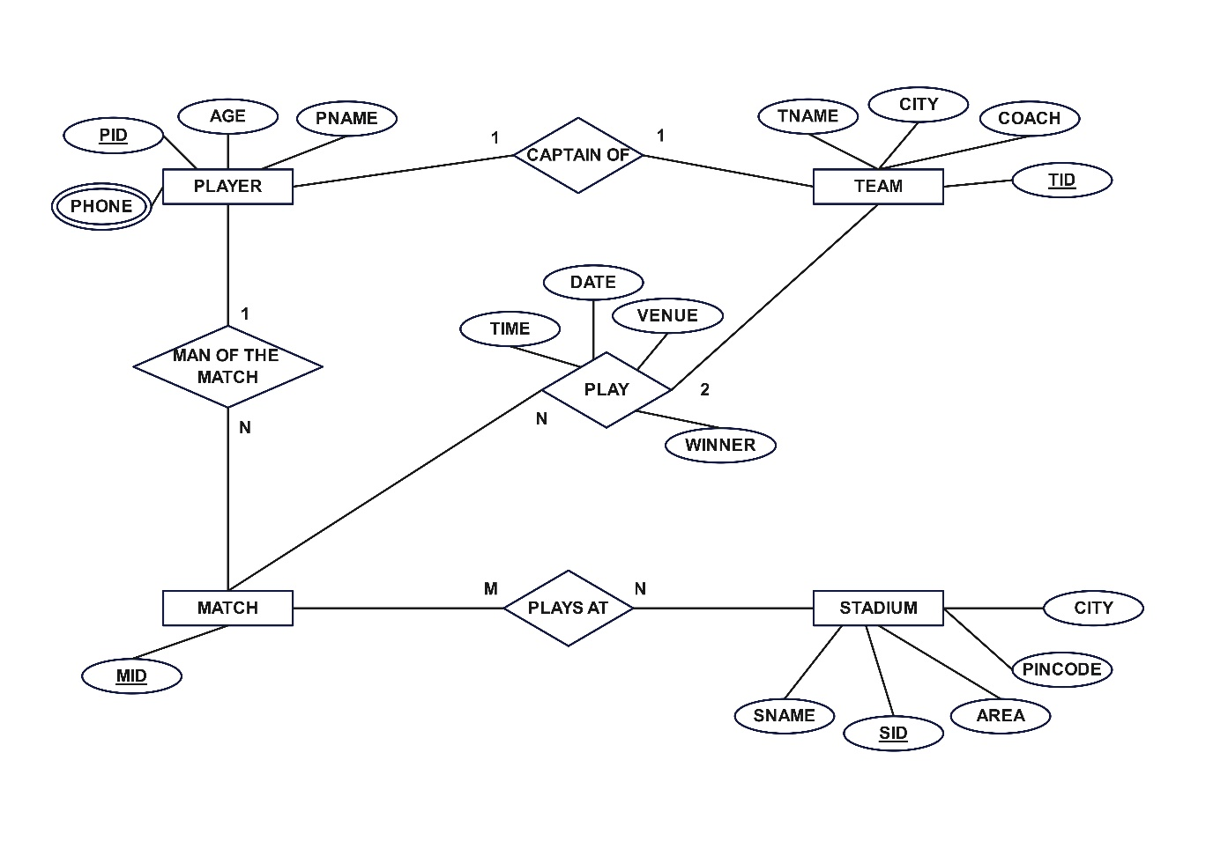

**SCHEMA**

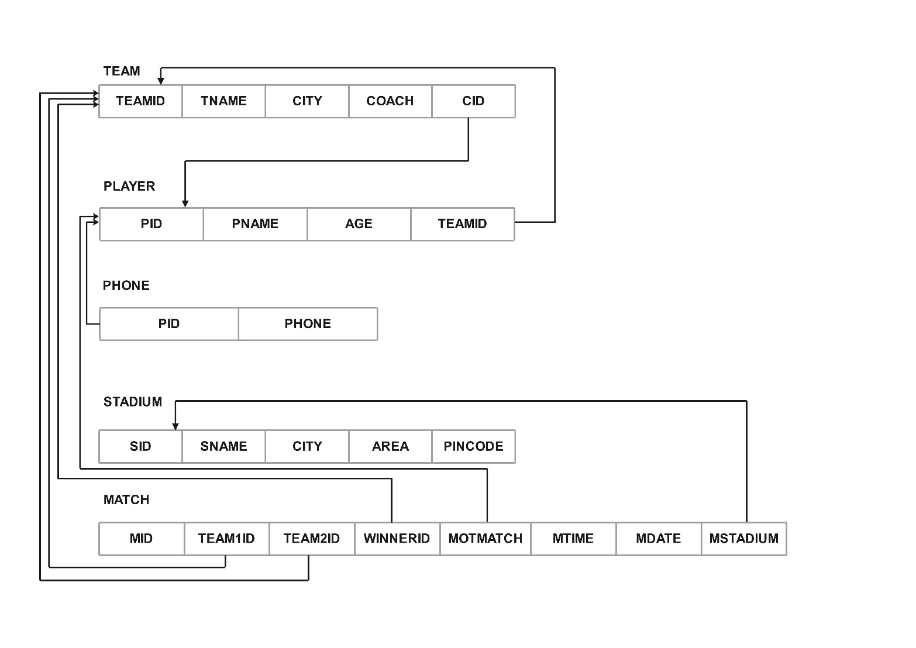

CREATE TABLE TEAM(

TEAMID INT PRIMARY KEY,

TNAME VARCHAR(30),

CITY VARCHAR(30),

COACH VARCHAR(30),

CID INT

);

INSERT INTO TEAM VALUES (1,'RCB','BANGALORE','RAHUL',1);

INSERT INTO TEAM VALUES (2,'CSK','CHENNAI','AKBAR',2);

INSERT INTO TEAM VALUES (3,'MI','MUMBAI','ANTONY',3);

INSERT INTO TEAM VALUES (4,'GT','GUJARAT','RAHUL DRAVID',4);

CREATE TABLE PLAYER(

PID INT PRIMARY KEY,

PNAME VARCHAR(30),

AGE INT,

TEAMID INT REFERENCES TEAM(TEAMID)

);

INSERT INTO PLAYER VALUES (1,'VIRAT',35,1);

INSERT INTO PLAYER VALUES (2,'DHONI',40,2);

INSERT INTO PLAYER VALUES (3,'ROHITH',39,3);

INSERT INTO PLAYER VALUES (4,'HARDIK',30,4);

INSERT INTO PLAYER VALUES (5,'K L RAHUL',32,1);

ALTER TABLE TEAM

ADD FOREIGN KEY (CID) REFERENCES PLAYER(PID);

CREATE TABLE PHONE(

PID INT REFERENCES PLAYER(PID),

PHONE VARCHAR(20)

);

INSERT INTO PHONE VALUES (1,'9999999999');

INSERT INTO PHONE VALUES (2,'9999999998');

INSERT INTO PHONE VALUES (3,'9999999997');

INSERT INTO PHONE VALUES (4,'9999999996');

INSERT INTO PHONE VALUES (5,'9999999995');

INSERT INTO PHONE VALUES (1,'9999999994');

CREATE TABLE STADIUM(

SID INT PRIMARY KEY,

SNAME VARCHAR(30),

CITY VARCHAR(30),

AREA VARCHAR(30),

PINCODE INT

);

INSERT INTO STADIUM VALUES(1,'CHINNASWAMY','BANGALORE','MG ROAD','560092');

INSERT INTO STADIUM VALUES(2,'KANTEERAVA','DELHI','MAIN ROAD','560093');

INSERT INTO STADIUM VALUES(3,'MODI','GUJARAT','CITY','560094');

CREATE TABLE MATCH(

MID INT PRIMARY KEY,

TEAM1ID INT REFERENCES TEAM(TEAMID),

TEAM2ID INT REFERENCES TEAM(TEAMID),

WINNERID INT REFERENCES TEAM(TEAMID),

MOTMATCH INT REFERENCES PLAYER(PID),

MTIME VARCHAR(10),

MDATE DATE,

MSTADIUM INT REFERENCES STADIUM(SID)

);

INSERT INTO MATCH VALUES(1,1,2,1,1,'7PM','12-JAN-23',1);

INSERT INTO MATCH VALUES(2,1,3,1,1,'7PM','13-JAN-23',3);

INSERT INTO MATCH VALUES(3,1,4,1,5,'7PM','14-JAN-23',1);

INSERT INTO MATCH VALUES(4,4,2,2,2,'7PM','15-JAN-23',2);

INSERT INTO MATCH VALUES(5,1,2,1,5,'7PM','16-JAN-23',1);

**NOTE: IF ABOVE DATE FORMAT NOT WORKS TRY THIS ONE**

**INSERT INTO MATCH VALUES(5,1,2,1,5,'7PM','2023-01-16',1);**

**1 Display the youngest player (in terms of age) Name, Team name , age in which he belongs of the tournament.**

SELECT PNAME, TNAME, AGE

FROM PLAYER P, TEAM T

WHERE P.TEAMID = T.TEAMID AND AGE = (SELECT MIN(AGE) FROM PLAYER);

PNAME TNAME AGE

------------ ----------- -----

HARDIK GT 30

**2 List the details of the stadium where the maximum number of matches were played.**

SELECT *

FROM STADIUM

WHERE SID IN (

SELECT MSTADIUM

FROM MATCH

GROUP BY MSTADIUM

HAVING COUNT(MSTADIUM) = (

SELECT MAX(COUNTS) FROM (

SELECT COUNT(*) COUNTS

FROM MATCH

GROUP BY MSTADIUM) COUNTER

)

);

SID SNAME CITY AREA PINCODE

--- ------------------ --------------- ------------- ----------

1 CHINNASWAMY BANGALORE MG ROAD 560092

**3 List the details of the player who is not a captain but got the man_of _match award at least in two matches.**

SELECT *

FROM PLAYER

WHERE PID IN (

SELECT MOTMATCH

FROM MATCH

GROUP BY MOTMATCH

HAVING COUNT(MOTMATCH)>=2

) AND PID NOT IN (SELECT CID FROM TEAM);

PID PNAME AGE TEAMID

--- ------------------------------ ---------- ----------

5 K L RAHUL 32 1

**4 Display the Team details who won the maximum matches.**

SELECT *

FROM TEAM

WHERE TEAMID IN (

SELECT WINNERID

FROM MATCH

GROUP BY WINNERID

HAVING COUNT(WINNERID) = (

SELECT MAX(COUNTS) FROM(

SELECT COUNT(*) COUNTS

FROM MATCH

GROUP BY WINNERID) COUNTER

)

);

TEAMID TNAME CITY COACH CID

---------- -------------- ----------------- ---------- ----

1 RCB BANGALORE RAHUL 1

**5 Display the team name where all its won matches played in the same stadium.**

SELECT TNAME

FROM TEAM, MATCH

WHERE TEAMID = WINNERID

GROUP BY TNAME

HAVING COUNT(DISTINCT MSTADIUM) = 1;

TNAME

-------

CSK

**4. A country wants to conduct an election for the parliament. A country having many constituencies. Each constituency is identified uniquely by Constituency_id, having the Name, belongs to a state,Number_of_voters. A constituency can have many voters. Each voter is uniquely identified by using Voter_id, having the Name, age, address (involves Houseno,city,state,pincode). Each voter belongs to only one constituency. There are many candidates contesting in the election. Each candidates are uniquely identified by using candidate_id, having Name, phone_no, age, state. A candidate belongs to only one party.Thereare many parties. Each party is uniquely identified by using Party_id, having Party_Name,Party_symbol. A candidate can contest from many constituencies under a same party. A party can have many candidates contesting from different constituencies. No constituency having the candidates from the same party. A constituency can have many contesting candidates belongs to different parties. Each voter votes only one candidate of his/her constituencty.**

Queries:

i. List the details of the candidates who are contesting from more than one constituencies which are belongs to different states.

ii. Display the state name having maximum number of constituencies.

iii. Create a stored procedure to insert the tuple into the voter table by checking the voter age. If voter‟s age

is at least 18 years old, then insert the tuple into the voter else display the “Not an eligible voter msg”.

iv. Create a stored procedure to display the number_of_voters in the specified constituency. Where the constituency name is passed as an argument to the stored procedure.

v. Create a TRIGGER to UPDATE the count of “ Number_of_voters” of the respective constituency in “CONSTITUENCY”table , AFTER inserting a tuple into the “VOTERS”table.

**SCHEMA**

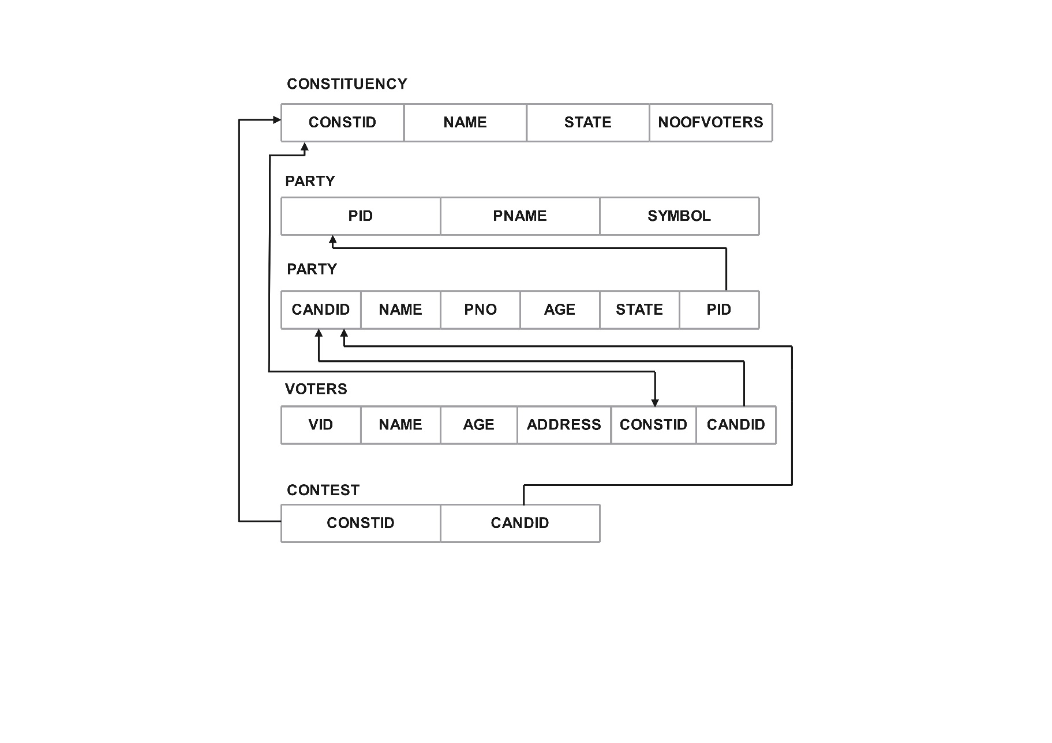

CREATE TABLE CONSTITUENCY(

CONSTID INT PRIMARY KEY,

NAME VARCHAR(30),

STATE VARCHAR(30),

NOOFVOTERS INT

);

INSERT INTO CONSTITUENCY VALUES(1,'BANGALORE','KARNATAKA',2);

INSERT INTO CONSTITUENCY VALUES(2,'SHIMOGA','KARNATAKA',2);

INSERT INTO CONSTITUENCY VALUES(3,'HYDARABAD','TELANGANA',3);

CREATE TABLE PARTY(

PID INT PRIMARY KEY,

PNAME VARCHAR(30),

SYMBOL VARCHAR(30)

);

INSERT INTO PARTY VALUES(1,'CONGRESS','PALM');

INSERT INTO PARTY VALUES(2,'BJP','LOTUS');

CREATE TABLE CANDIDATE(

CANDID INT PRIMARY KEY,

NAME VARCHAR(30),

PNO VARCHAR(30),

AGE INT,

STATE VARCHAR(30),

PID INT REFERENCES PARTY(PID)

);

INSERT INTO CANDIDATE VALUES(1,'AMAR','8660639260',35,'KARNATAKA',1);

INSERT INTO CANDIDATE VALUES(2,'ANTONY','8660639262',37,'TELANGANA',2);

CREATE TABLE VOTERS(

VID INT,

NAME VARCHAR(30),

AGE VARCHAR(30),

ADDRESS VARCHAR(150),

CONSTID INT REFERENCES CONSTITUENCY(CONSTID),

CANDID INT REFERENCES CANDIDATE(CANDID)

);

INSERT INTO VOTERS VALUES(1,'ABHI',20,'1 BALKI BIDAR KARNATAKA 577001',1,1);

INSERT INTO VOTERS VALUES(2,'ARIF',20,'1 BHADRAVATHI BHADRAVATHI KARNATAKA 577201',2,2);

INSERT INTO VOTERS VALUES(3,'MANOJ',18,'1 ANAVERI SHIMOGA KARNATAKA 577243',1,2);

CREATE TABLE CONTEST(

CONSTID INT REFERENCES CONSTITUENCY(CONSTID),

CANDID INT REFERENCES CANDIDATE(CANDID)

);

INSERT INTO CONTEST VALUES(1,1);

INSERT INTO CONTEST VALUES(2,2);

INSERT INTO CONTEST VALUES(3,1);

**i. List the details of the candidates who are contesting from more than one**

**constituencies which are belongs to different states.**

SELECT *

FROM CANDIDATE

WHERE CANDID IN (

SELECT CANDID

FROM CONTEST CT, CONSTITUENCY CS

WHERE CT.CONSTID = CS.CONSTID

GROUP BY CANDID

HAVING COUNT(DISTINCT(STATE))>1

);

CANDID NAME PNO AGE STATE

---------- --------- --------------- ---- ----------

1 AMAR 8660639260 35 KARNATAKA

**ii. Display the state name having maximum number of constituencies.**

SELECT STATE FROM CONSTITUENCY

GROUP BY STATE

HAVING COUNT(STATE) = (

SELECT MAX(COUNTS) FROM (

SELECT COUNT(*) COUNTS

FROM CONSTITUENCY

GROUP BY STATE) COUNTER

);

STATE

----------------

KARNATAKA

**iii. Create a stored procedure to insert the tuple into the voter table by checking the voter age. If voter's age is at least 18 years old, then insert the tuple into the voter else display the "Not an eligible voter msg".**

**FOR ORACLE**

CREATE OR REPLACE PROCEDURE CHECKAGE(ID IN NUMBER,AGE IN NUMBER)

AS

BEGIN

IF AGE>=18 THEN

INSERT INTO VOTERS(VID,AGE)VALUES(ID,AGE);

ELSE

DBMS_OUTPUT.PUT_LINE('NOT AN ELIGIBLE VOTER');

END IF;

END;

Procedure created.

SQL> **SET SERVEROUTPUT ON**;

SQL> **EXEC CHECKAGE(4,17);**

NOT AN ELIGIBLE VOTER

PL/SQL procedure successfully completed.

SQL> **EXEC CHECKAGE(3,22);**

PL/SQL procedure successfully completed.

**FOR MYSQL**

DELIMITER //

CREATE PROCEDURE CHECKAGE(IN ID INT, IN AGE INT)

BEGIN

IF AGE >= 18 THEN

INSERT INTO VOTERS (VID, AGE) VALUES (ID, AGE);

ELSE

SELECT 'NOT AN ELIGIBLE VOTER' AS Message;

END IF;

END//

DELIMITER ;

CALL CHECKAGE(5,12)

Message

-----------------------------------

NOT AN ELIGIBLE VOTER

**iv. Create a stored procedure to display the number_of_voters in the specified constituency.**

**Where the constituency name is passed as an argument to the stored procedure.**

**FOR ORACLE**

CREATE OR REPLACE PROCEDURE COUNTVOTERS(CNAME IN VARCHAR)

AS

CNT INTEGER;

BEGIN

SELECT NOOFVOTERS INTO CNT

FROM CONSTITUENCY

WHERE NAME = CNAME;

DBMS_OUTPUT.PUT_LINE ( 'TOTAL VOTERS ARE: ' || CNT);

END;

/

Procedure created.

SQL> **EXEC COUNTVOTERS('SHIMOGA'**);

TOTAL VOTERS ARE: 2

PL/SQL procedure successfully completed.

**FOR MYSQL**

DELIMITER //

CREATE PROCEDURE COUNTVOTERS(IN CNAME VARCHAR(255))

BEGIN

DECLARE CNT INT;

SELECT NOOFVOTERS INTO CNT

FROM CONSTITUENCY

WHERE NAME = CNAME;

IF CNT IS NOT NULL THEN

SELECT CONCAT('TOTAL VOTERS ARE: ', CNT) AS Message;

END IF;

END//

CALL COUNTVOTERS(‘SHIMOGA’);

Message

---------------------------

TOTAL VOTERS ARE: 2

**v. Create a TRIGGER to UPDATE the count of "Number_of_voters" of the respective constituency in "CONSTITUENCY" table , AFTER inserting a tuple into the "VOTERS" table.**

**FOR ORACLE**

CREATE OR REPLACE TRIGGER UPDATECOUNT

AFTER INSERT ON VOTERS

FOR EACH ROW

BEGIN

UPDATE CONSTITUENCY

SET NOOFVOTERS = NOOFVOTERS + 1

WHERE CONSTID=:NEW.CONSTID;

END;

/

Trigger created.

**FOR MYSQL**

FOR MYSQL

DELIMITER //

CREATE TRIGGER UPDATECOUNT AFTER INSERT ON VOTERS

FOR EACH ROW

BEGIN

UPDATE CONSTITUENCY

SET NOOFVOTERS = NOOFVOTERS + 1

WHERE CONSTID = NEW.CONSTID;

END//

DELIMITER ;

INSERT INTO VOTERS VALUES(10,'AKSHAY',22,'1 BALKI BIDAR KARNATAKA 577002',1,1);

**5. Design an ER-diagram for the following scenario, Convert the same into a relational model, normalize Relations into a suitable Normal form and then solve the following queries. A country can have many Tourist places . Each Tourist place is identified by using tourist_place_id, having a name, belongs to a state, Number of kilometers away from the capital city of that state,history. There are many Tourists visits tourist places every year. Each tourist is identified uniquely by using Tourist_id, having a Name, age, Country and multiple emailids. A tourist visits many Tourist places, it is also required to record the visted_date in the database. A tourist can visit a Tourist place many times at different dates. A Tourist place can be visited by many tourists either in the same date or at different dates.**

Queries:

i. List the state name which is having maximum number of tourist places.

ii. List details of Tourist place where maximum number of tourists visited.

iii. List the details of tourists visited all tourist places of the state “KARNATAKA”.

iv. Display the details of the tourists visited at least one tourist place of the state, but visited all states tourist places.

v. Display the details of the tourist place visited by the tourists of all country.

**ER DIAGRAM**

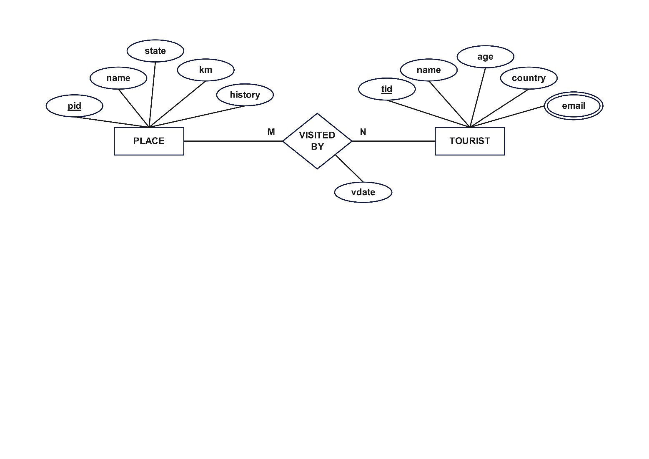

**SCHEMA**

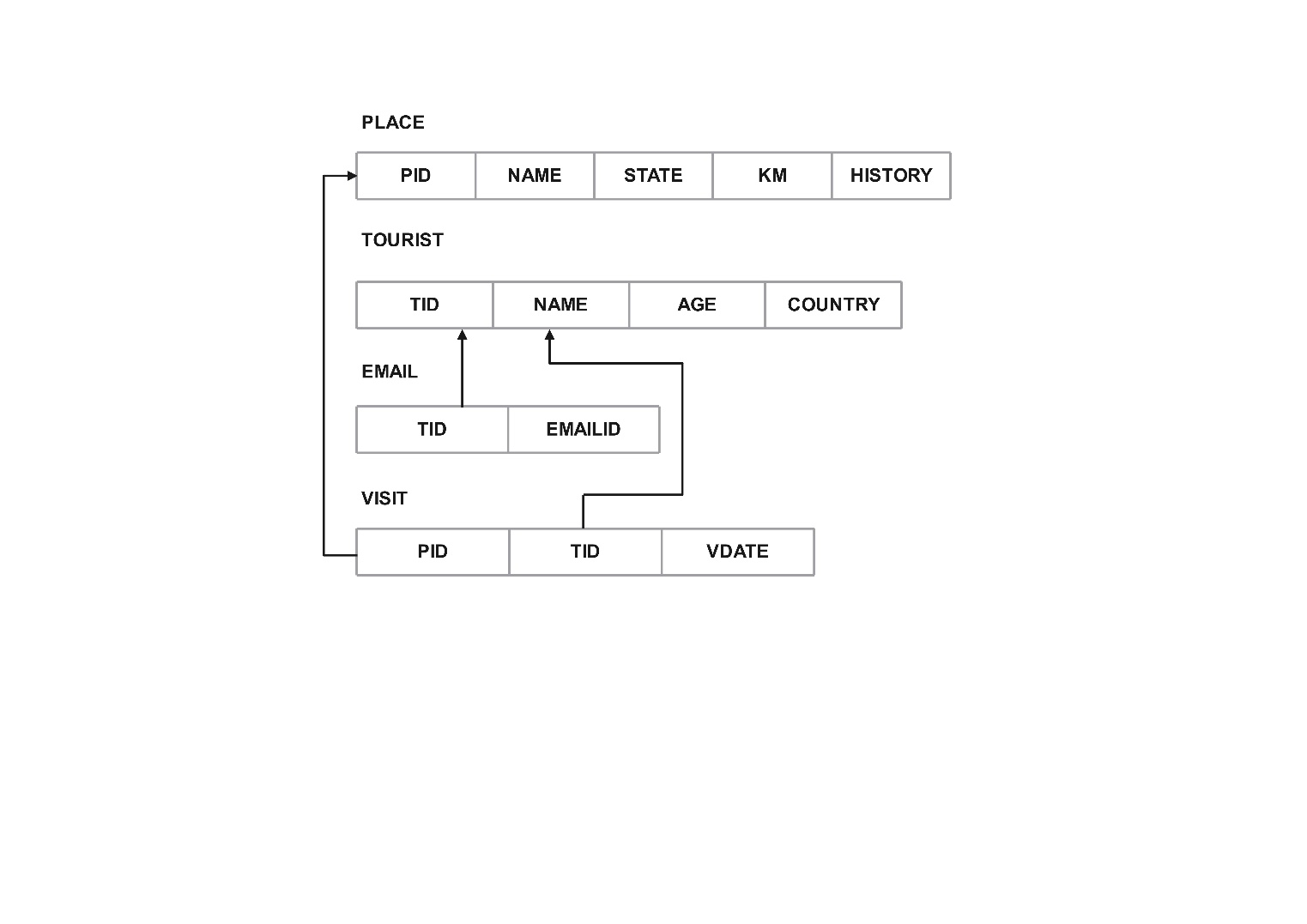

CREATE TABLE TOURIST (

TID INT PRIMARY KEY,

NAME VARCHAR(30),

AGE INT,

COUNTRY VARCHAR(30)

);

INSERT INTO TOURIST VALUES (1,'AMAR',21,'INDIA');

INSERT INTO TOURIST VALUES (2,'AKBAR',22,'INDIA');

INSERT INTO TOURIST VALUES (3,'ANTONY',20,'UK');

INSERT INTO TOURIST VALUES (4,'RAM',25,'US');

CREATE TABLE EMAIL(

TOURISTID INT REFERENCES TOURIST(TID),

EMAIL VARCHAR(50)

);

INSERT INTO EMAIL VALUES(1,'AMAR@GMAIL.COM');

INSERT INTO EMAIL VALUES(1,'AMAR.P@GMAIL.COM');

INSERT INTO EMAIL VALUES(2,'AKBARAMAR@GMAIL.COM');

INSERT INTO EMAIL VALUES(3,'ANTONY@GMAIL.COM');

INSERT INTO EMAIL VALUES(4,'RAM@GMAIL.COM');

CREATE TABLE PLACE(

PID INT PRIMARY KEY,

NAME VARCHAR(50),

STATE VARCHAR(50),

KM INT,

HISTORY VARCHAR(200)

);

INSERT INTO PLACE VALUES(1,'JOG FALSE','KARNATAKA',400,'WATER FALSE');

INSERT INTO PLACE VALUES(2,'MYSORE','KARNATAKA',150,'PALACE');

INSERT INTO PLACE VALUES(3,'TAJMAHAL','DELHI',100,'BURIAL');

INSERT INTO PLACE VALUES(4,'TIRUPATHI','AP',50,'TEMPLE');

CREATE TABLE VISIT(

TID INT REFERENCES TOURIST(TID),

PID INT REFERENCES PLACE(PID),

VISITDATE DATE

);

INSERT INTO VISIT VALUES(1,1,'12-JAN-2022');

INSERT INTO VISIT VALUES(2,1,'12-JAN-2022');

INSERT INTO VISIT VALUES(3,1,'12-JAN-2022');

INSERT INTO VISIT VALUES(4,1,'12-JAN-2022');

INSERT INTO VISIT VALUES(2,2,'12-JAN-2022');

INSERT INTO VISIT VALUES(2,3,'12-JAN-2022');

INSERT INTO VISIT VALUES(2,4,'12-JAN-2022');

**NOTE: IF ABOVE DATE FORMAT NOT WORKS TRY THIS ONE**

**INSERT INTO VISIT VALUES(2,4,'2022-01-12');**

**i. List the state name which is having maximum number of tourist places.**

SELECT STATE

FROM PLACE

GROUP BY STATE

HAVING COUNT(*) = (

SELECT MAX(COUNTS) FROM(

SELECT COUNT(*) COUNTS

FROM PLACE

GROUP BY STATE) COUNTER

);

STATE

----------

KARNATAKA

**ii. List details of Tourist place where maximum number of tourists visited.**

SELECT *

FROM PLACE

WHERE PID IN (

SELECT PID

FROM VISIT

GROUP BY PID

HAVING COUNT(*)= (

SELECT MAX(COUNTS) FROM (

SELECT COUNT(*) COUNTS

FROM VISIT

GROUP BY PID) COUNTER

)

);

PID NAME STATE KM HISTORY

------ --------------- --------------- ------- -------------

1 JOG FALSE KARNATAKA 400 WATER FALSE

**iii. List the details of tourists visited all tourist places of the state “KARNATAKA”.**

SELECT T.NAME, AGE, COUNTRY

FROM VISIT V, PLACE P, TOURIST T

WHERE V.PID = P.PID AND V.TID = T.TID AND STATE = 'KARNATAKA'

GROUP BY T.NAME, AGE, COUNTRY

HAVING COUNT(DISTINCT V.PID) = (

SELECT COUNT(*)

FROM PLACE

WHERE STATE = 'KARNATAKA'

);

NAME AGE COUNTRY

---------- -------- ----------

AKBAR 22 INDIA

**iv. Display the details of the tourists visited at least one tourist place of the state, but visited all states touristplaces.**

SELECT T.NAME, AGE, COUNTRY

FROM VISIT V, PLACE P, TOURIST T

WHERE V.PID = P.PID AND V.TID = T.TID

GROUP BY T.NAME, AGE, COUNTRY

HAVING COUNT(DISTINCT STATE) = (

SELECT COUNT(DISTINCT STATE)

FROM PLACE

);

NAME AGE COUNTRY

-----------------------------

AKBAR 22 INDIA

**v. Display the details of the tourist place visited by the tourists of all country**

SELECT P.NAME, KM, HISTORY

FROM VISIT V, PLACE P, TOURIST T

WHERE V.PID = P.PID AND V.TID = T.TID

GROUP BY P.NAME, KM, HISTORY

HAVING COUNT(DISTINCT COUNTRY) = (

SELECT COUNT(DISTINCT COUNTRY)

FROM TOURIST

);

NAME KM HISTORY

------------- ----- ------------

JOG FALSE 400 WATER FALSE